VOLUMES

In Kubernetes, a Volume is a storage abstraction that allows containers in a Pod to store and share data. Unlike the container’s ephemeral filesystem, which is destroyed when the container stops, a Kubernetes volume persists data for the lifetime of the Pod and can be shared among multiple containers within the same Pod.
A Volume in Kubernetes is a directory, possibly with some data in it, which is accessible to the containers in a Pod. Kubernetes volumes are designed to persist data beyond the lifetime of a container, allowing for data sharing between containers and stateful applications.

Types of Volumes in Kubernetes:
Kubernetes supports multiple types of volumes, each suited for different use cases:

1. emptyDir
- Created when a Pod is assigned to a node and exists as long as the Pod is running.
- Useful for temporary storage, scratch space, or cache.
- Data is deleted when the Pod is removed.

2. hostPath
- Mounts a file or directory from the host node’s filesystem into the Pod.
- Use with caution; often used for node-level tasks like logs or configuration files.

3. persistentVolumeClaim (PVC)
- Abstracts a PersistentVolume (PV) and allows Pods to request persistent storage.
- Supports dynamic provisioning if a StorageClass is defined.
- Commonly used for databases or long-term storage.

4. nfs
- Mounts an NFS share into the Pod.
- Good for shared storage across multiple Pods.

5. configMap
- Stores configuration data as files in a volume.
- Containers can mount it to read configuration without rebuilding images.

6. secret
- Stores sensitive information like passwords or tokens.
- Can be mounted as files inside a container.

7. hostPath
- Directly mounts a directory or file from the node filesystem.

Create EmptyDir:
emptyDir is a Kubernetes volume type that provides temporary storage for a Pod.
This storage is created when the Pod starts and is deleted automatically when the Pod is removed (not when the container restarts).
Define the Pod with an EmptyDir Volume: # vi emptydir-pod.yaml
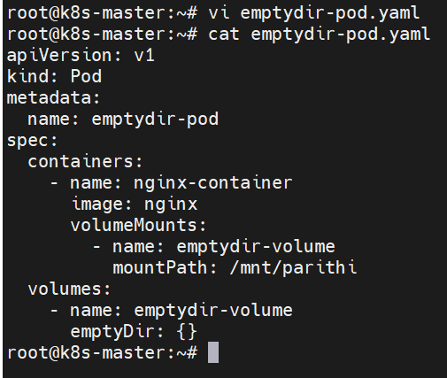

Create the Pod:
# kubectl apply -f my-emptydir-pod.yaml

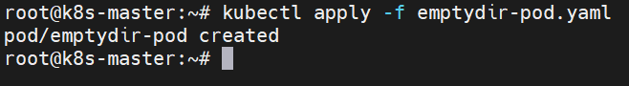

Verify the Pod and Volume:
# kubectl get pods my-emptydir-pod
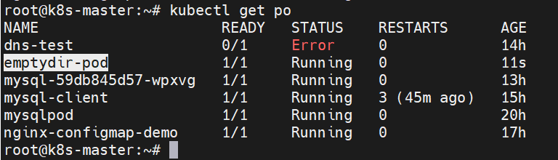

Login in to pod:
# kubectl exec -it my-emptydir-pod -- bash
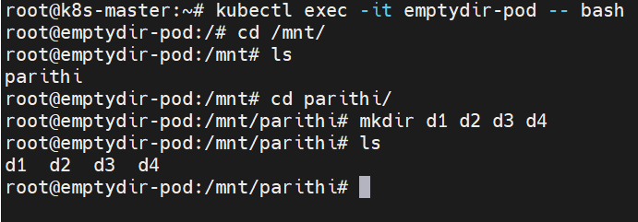

Delete pod:
# kubectl delete pod <pod name>
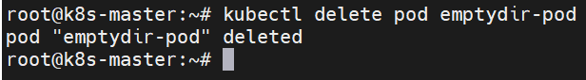
Any data you write to /mnt/data in this example will be lost if the Pod is removed from the node for any reason.

HostPath Volume:

hostPath is a Kubernetes volume type that mounts a file or directory from the host node’s filesystem into a Pod.
This means the pod can directly access files and directories on the node where it is running.

Create yaml file for hostpath volume:
# vi hostpath-pod.yaml
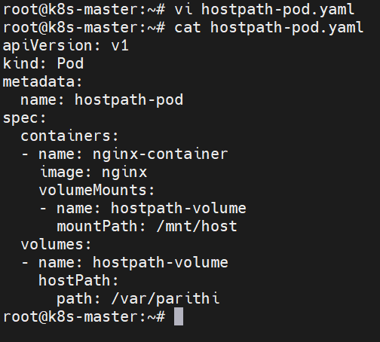

Create pod for hostpath volume:
# kubectl create hostpath.yaml

Delete the hostpath pod:
# kubectl delete pod hostpath pod
Even I deleted the pod in master node ,the data in the container saved in the host path in worker node.

NFS Volume in Kubernetes:

Step 1 – Pre-requisites
- Have a running NFS server (can be on another node or a cloud server).
- NFS export directory should exist and be shared. Example:
mkdir -p /shared
chown -R nobody:nogroup /shared
chmod 777 /shared

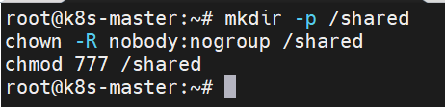

Step 2 – create yaml file.

Create yaml file for nfs volume:
# nfs-pod.yaml
apiVersion: v1 kind: Pod metadata:
name: my-nfs-pod spec:
containers:
- name: my-container image: nginx volumeMounts:

- name: my-nfs-volume mountPath: /mnt/nfs
volumes:
- name: my-nfs-volume nfs:
server: nfs-server.example.com path: /shared
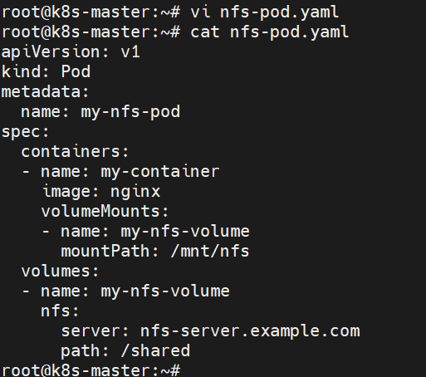
Step 3 – Apply the YAML
kubectl apply -f nfs-pod.yaml
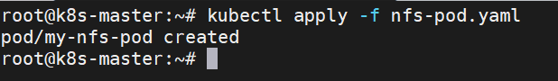

Step 4 – Verify NFS Volume Inside Pod
- Exec into the pod:
kubectl exec -it my-nfs-pod -- /bin/sh
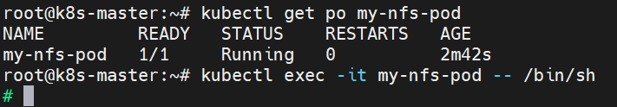

- Check the mounted NFS path:
df -h /mnt/nfs
ls /mnt/nfs
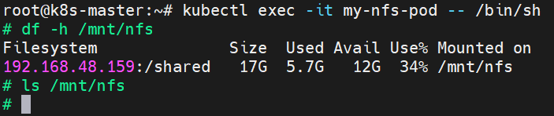
- Create a test file:
echo "Hello from pod" > /mnt/nfs/test.txt
cat /mnt/nfs/test.txt
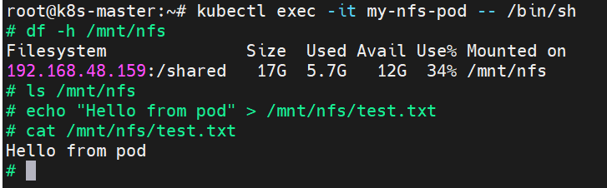
- Check on NFS server:
cat /shared/test.txt
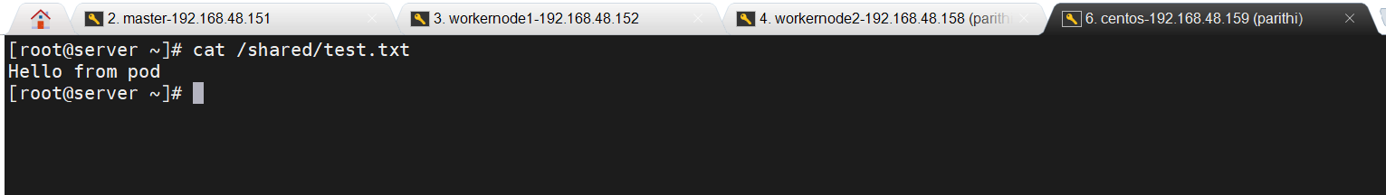
You should see Hello from pod — this proves data is persisted on NFS.

Step 5 – Cleanup
kubectl delete pod my-nfs-pod
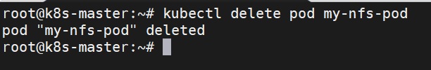
The NFS directory still retains files.
===============================================================

Troubleshoot:

1️⃣ Check Pod Events
Run:
kubectl describe pod my-nfs-pod
Look at the Events section at the bottom. You will likely see:
Warning FailedMount Unable to mount volumes for pod "my-nfs-pod": ...
mount.nfs: access denied by server while mounting 192.168.48.159:/shared
This tells you why the Pod cannot start.

2️⃣ Possible Causes
- NFS server not running:
systemctl status nfs-server
- NFS export not configured correctly:
Check /etc/exports on NFS server:
/shared *(rw,sync,no_root_squash,no_subtree_check)
Reload exports:
exportfs -r
- Firewall blocking NFS (port 2049):
ufw status
# or iptables -L
- Worker nodes cannot reach NFS server:
Test from each worker:
showmount -e 192.168.48.159
mount -t nfs 192.168.48.159:/shared /mnt
If it fails, fix network or firewall issues.

3️⃣ Check Kubernetes Node Logs
Sometimes the worker kubelet cannot mount the NFS volume. On each worker:
journalctl -u kubelet -f
Look for NFS mount errors.

4️⃣ Correct YAML (if needed)
volumes:
- name: my-nfs-volume
nfs:
server: 192.168.48.159
path: /shared
- Use IP address, not hostname, unless DNS resolves from nodes.
- Make sure the path /shared exists on the NFS server.

